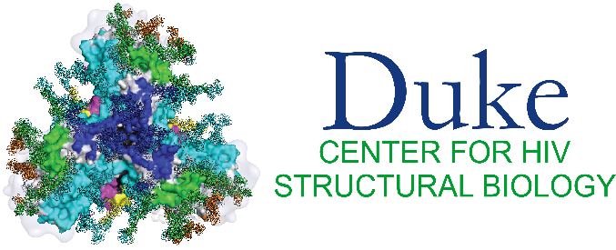

**DCHSB U54 funded research publications**

**2023**

1. Henderson R, Anasti K, Manne K, et al. Engineering immunogens that select for specific mutations in HIV broadly neutralizing antibodies. bioRxiv 2023 (In eng). DOI: 10.1101/2023.12.15.571700.

2. Henderson R, Zhou Y, Stalls V, et al. Structural basis for breadth development in the HIV-1 V3-glycan targeting DH270 antibody clonal lineage. Nat Commun 2023;14(1):2782. DOI: 10.1038/s41467-023-38108-1.

3. Huang Q, Zhou Y, Liu HF, Bartesaghi A. Multiple-image super-resolution of cryo-electron micrographs based on deep internal learning. Biol Imaging 2023;3:e3. DOI: 10.1017/S2633903X2300003X.

4. Liu HF, Zhou Y, Huang Q, et al. nextPYP: a comprehensive and scalable platform for characterizing protein variability in situ using single-particle cryo-electron tomography. Nat Methods 2023. DOI: 10.1038/s41592-023-02045-0.

5. May AJ, Pothula KR, Janowska K, Acharya P. Structures of Langya Virus Fusion Protein Ectodomain in Pre- and Postfusion Conformation. J Virol 2023;97(6):e0043323. DOI: 10.1128/jvi.00433-23.

6. Ratnapriya S, Pothula KR, Dam KA, et al. Conformational flexibility of HIV-1 envelope glycoproteins modulates transmitted / founder sensitivity to broadly neutralizing antibodies. bioRxiv 2023. DOI: 10.1101/2023.09.13.557082.

7. Weber N, Hinks B, Jensen J, Lidahl T, Mendonça L. Sample Preparation for In Situ Cryotomography of Mammalian Cells. J Vis Exp 2023(202) (In eng). DOI: 10.3791/65697.

8. Williams WB, Alam SM, Ofek G, et al. Vaccine Induction of Heterologous HIV-1 Neutralizing Antibody B Cell Lineages in Humans. medRxiv 2023:2023.03.09.23286943. DOI: 10.1101/2023.03.09.23286943.

**2024**

9. Ao Y, Grover JR, Gifford L, et al. Bioorthogonal click labeling of an amber-free HIV-1 provirus for in-virus single molecule imaging. Cell Chem Biol 2024;31(3):487-501.e7. (In eng). DOI: 10.1016/j.chembiol.2023.12.017.

10. Bennett AL, Edwards R, Kosheleva I, et al. Microsecond dynamics control the HIV-1 Envelope conformation. Sci Adv 2024;10(5):eadj0396. DOI: 10.1126/sciadv.adj0396.

11. Do HN, Zhao M, Alam SM, Gnanakaran S. Dynamics and Activation of Membrane-Bound B Cell Receptor Assembly. bioRxiv 2024:2024.07.10.602784. DOI: 10.1101/2024.07.10.602784.

12. Jin W, Zhou Y, Bartesaghi A. Accurate size-based protein localization from cryo-ET tomograms. Journal of Structural Biology: X 2024:100104.

13. Saunders KO, Counts J, Thakur B, et al. Vaccine induction of CD4-mimicking HIV-1 broadly neutralizing antibody precursors in macaques. Cell 2024;187(1):79-94.e24. (In eng). DOI: 10.1016/j.cell.2023.12.002.

14. Watson AJI, Bartesaghi A. Advances in cryo-ET data processing: meeting the demands of visual proteomics. Curr Opin Struct Biol 2024;87:102861. DOI: 10.1016/j.sbi.2024.102861.